Curriculum Vitae
personal Information
Name | Hala Ahmed Mohamed Abdelhady | 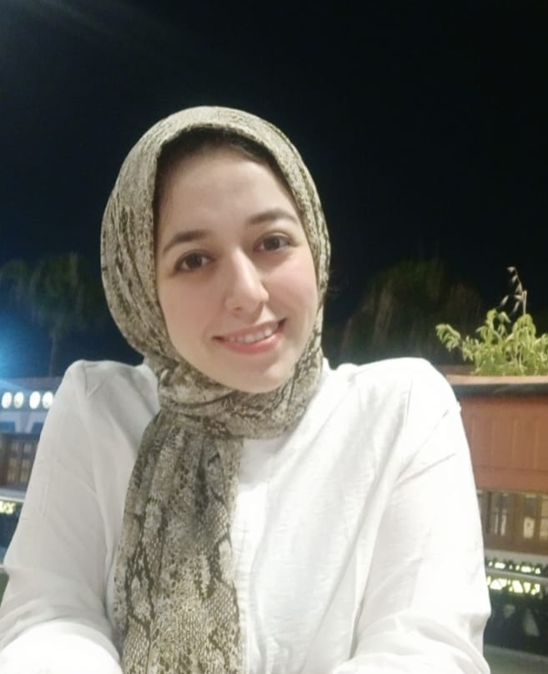
Title | Demonstrator at department of nutrition & clinical nutrition at faculty of veterinary medicine , Cairo university .
Date of birth | 25/7/1994
Place of birth | Cairo, Egypt
Citizenship | Egyptian
Contact Information
Home phone
Work phone
Mobile phone | 01062450434
E-mail (s) | halaa8397@gmail.com
Web site (s)
Current Address | Obour city
Educational Qualifications
BVSc 2018, Cairo University
Academic Positions
Demonstrator at department of nutrition & clinical nutrition at faculty of veterinary medicine , Cairo university .
Thesis Title
Some dietary interventions to improve gastrointestinal physiology and promote health status of dogs
Areas of experience
Projects
Awards
Professional Qualifications
Conferences

Training courses at FLDC: ادارة الازمات- التفكير الناقد –اساسيات التعليم المدمج-نظم الامتحانات و تقويم الطلاب – المقررات الالكترونية التفاعلية

Computer Skills
Good at Microsoft office skills

Language Skills
Arabic( native) English ( Good at writing & reading)
Professional Memberships
Other activities
List of publications

Publications statistic
Journal’s Publication |  | Conference’s Publication |  | Authors |  |  | Total
Local | International | Local | International | Single | Shared |  | Total
 |  |  |  |  | Internal | External | Total

